IUPAC Naming

* Find the longest chain
* Determine the highest priority group → suffix
* Least combination → prefix
* Arranged in alphabetical order

Priority

* Carboxylic acid > anhydride > ester > amide > aldehyde > ketone > alcohol > alkene or alkyne > alkane

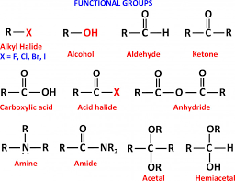

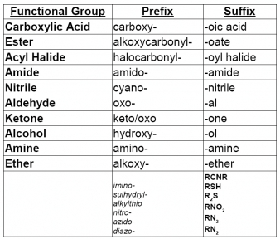

|  |  |
| --- | --- |
| IUPAC Name | Common Name |
| Methanal | Formaldehyde |
| Ethanal | Acetaldehyde |
| Propanal | Propioaldehyde |
| Propanone | Acetone |